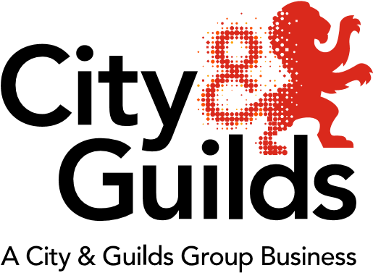

All about Business
Issue 1
May 2018

Welcome to our first edition newsletter from City & Guilds highlighting professional and technical education updates in business skills for all nations.

In this issue we’ll cover:
- Apprenticeship standards and end-point assessment (EPA) update
- EPA guidance documentation
- On-programme qualification update
- Resources to support both on-programme and EPA
- Webinar – Taking a closer look at EPA activities
- Customer Service Practitioner apprenticeship network events
- Apprenticeship standards (england) recorded webinars and future webinars
- T levels – What you need to know (England)
- Post-16 Skills Plan Consultation (England)
- Trailblazer apprenticeship standards
- Introducing our new Technical Adviser and team

Apprenticeship standards and EPA update

City & Guilds are now approved for 41 apprenticeship standards on the register of EPA organisations

Business Administrator apprenticeship EPA approval
We are pleased to announce that City & Guilds has been approved by the IfA for EPA for the Business Administrator apprenticeship standard. Walled Garden is now open for Business Administrator (9473-12) EPA registrations. Please refer to the EPA guidance documentation below for details regarding the EPA approval and bookings process.

EPA bookings will be open from July for the first EPAs available to take place in October 2018.

Customer Service Practitioner – City & Guilds are approved for EPA and open for EPA registrations and bookings 9794-12.

Please register learners on the above in order to access the EPA preparation tool and EPA guidance packs and recording forms. The EPA preparation tool will be available soon for Business Administrator and the EPA packs will be available at the end of May 2018. We now have a Business Administrator sample knowledge test available on the website for approved centres.

Customer Service Specialist – Standard approved, assessment plan has been submitted for approval by IfA. We will provide an update as soon as we receive confirmation.

EPA manual for the EPA service (centre guidance)

Our City & Guilds EPA manual details the processes for the EPA service, including the application, booking and registration, the assessment procedure, results and post-results including resits, the appropriate fees and the quailty assurance process.

Other resources available include our EPA Walled Garden user guide, which outlines how to book.

EPA preparation tool (apprentice)

Our EPA preparation tool is designed to help apprentices feel ready for their EPA by accessing a range of content online that they tailor to their standard and to their confidence levels. Watch our short video voiced by an apprentice to find out more.

Webinar – Taking a closer look at end point assessment (EPA) activities

This webinar covers the full EPA process from our current position as an EPA organisation, key steps in the apprenticeship journey and the vital evidence and skills required for an apprentice to successfully complete their training.

Watch webinar recording

Presented by Clair Seago, EPA Service Operations Manager
Webinar information correct at time of broadcast: 10 January 2018

On- programme optional qualification update

- 2794-02 new Customer Service Practitioner qualification is now available. The qualification has been developed to align to the Customer Service Practitioner apprenticeship standard.

- 3473-03 new Business Administrator qualification is now available. The qualification has been developed to align to the Business Administrator apprenticeship standard.

Resources to support on-programme and EPA preparation
New SmartScreen offer for Customer Service Practitioner and Business Administrator (additional resources are also in development).

We’re pleased to announce the launch of our new SmartScreen offer to support the following apprenticeship standards:

- Customer Service Practitioner enhanced SmartScreen (9794)
Price: £850 +VAT, Code: SS9794L2E
This package includes interactive learner resources. The tutor facing part of this package will be added in May 2018.

- Customer Service Practitioner apprenticeship training manual (electronic version) is now available to purchase on SmartScreen. Price: £350 +VAT, Code: SS543602-L2.

- Customer Service Practitioner apprenticeship training manual (hard copy) can now be ordered on the Walled Garden. Code: SS543602-L2 Price: £30 per copy plus P & P.

- Business Administrator Apprentice Training Manual (electronic version) is now availble to purchase on SmartScreen. Price £350 + VAT. Code: SS241017-L3.

- Business Administrator apprenticeship training manual (hard copy) available summer 2018

The apprenticeship training manual is designed to help ensure that learners gain experience in each of the standards required and it should be seen as a supporting resource. Use of the manual will aid employers and training providers in delivering the 20% off-the-job training requirement that is part of every apprenticeship programme, because the tasks can be completed away from the workplace.

We’re also developing additional SmartScreen resources for Business Administrator which will be available soon. Please email directsales@cityandguilds.com if you require additional information regarding the resources available.

Customer Service Practitioner apprenticeship network events

Due to high demand we’re currently in the process of planning additional Network Events for both Customer Service Practitioner and Business Administrator apprenticeship standards. Priority will be given to centres who have registered for EPA as places are in high demand and limited.

If you are willing to host a Customer Service Practiotioner/Business Administrator Network Event please email businessquals@cityandguilds.com. Alternatively please contact Dominic Green or Mandy Slaney directly as per the contact details below.

Apprenticeship standards (England) recorded webinars on our Business Administrator and Customer Service Practitioner offer

Access recorded webinars, slides and FAQ documents for both the Customer Service Practitioner and Business Administrator new apprenticeship offers:

Click on ‘Past events’ and then on ‘Transitioning to the New Standards - Webinar Series’
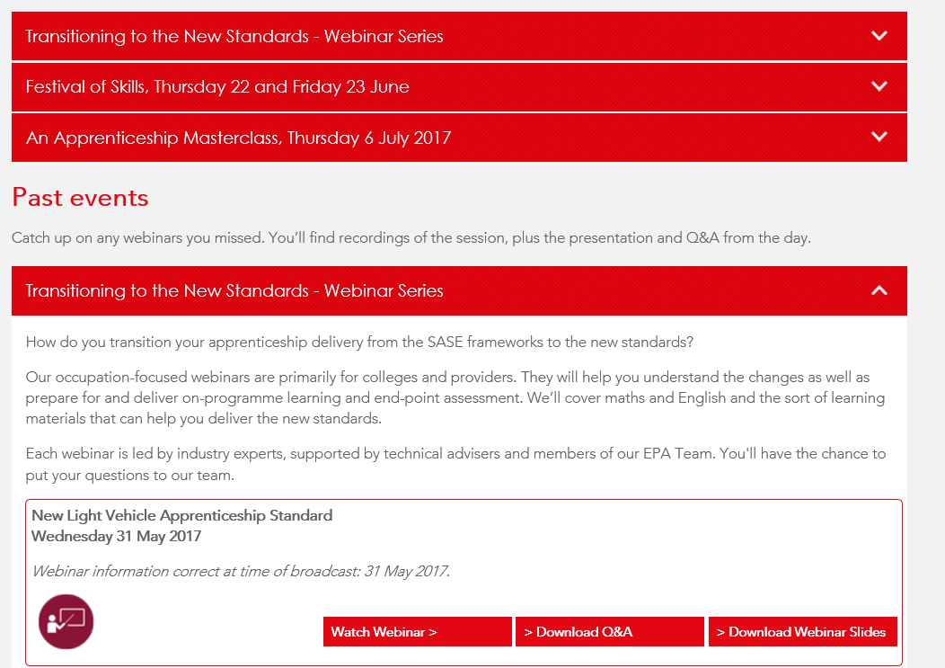

Future webinars
We are now planning “Next steps” webinars for both Customer Service Practitioner and Business Administrator to provide a further update and guidance on EPA preparation which will include approval, booking EPA and preparing for EPA.

Trailblazer apprenticeship standards – England

To check the status of standards currently in development, please visit the Government website.

As of January 2018, no further apprenticeship frameworks will be withdrawn until 2020 – read more.

T levels - What you need to know

The DfE have recently announced their action plan for the technical education reforms (T levels), expected to take effect from September 2020. The reforms began with the publication of the Post 16 Skills Plan in July 2016, and we now have more information to share with you.

To help you to understand what the changes will mean to you and your colleagues and how to prepare for them, we ran a free webinar this autumn for principals, vice principals, curriculum managers, tutors and anyone who is involved in delivering qualifications to full-time learners aged 16-18.

This webinar provides:
- an in-depth knowledge of the post 16 technical education reforms
- more information about T levels
- information about the new work placement pilot scheme
- information about the consultation process and how you can get involved.

Please note that the information in this webinar is correct as of the date of airing on 29 November 2017.

See events and click under ‘past events’.

Register for further email updates.

Post-16 Skills Plan consultation – England

Public consultation on the new T-level reforms closed on 8 February 2018. For more information regarding T levels please visit the City & Guilds webpage.

Welcome to the City & Guilds Business Skills team

Introducing our new Technical Adviser for Business – Dominic Green

I’m a husband, a father of two, a friend to a few and now the new City & Guilds Technical Advisor for Business! 2018 has certainly started off with a bang. As 2017 ended, I left behind 15 years experience of teaching in the FE sector in Business and IT. Having learned my trade in two great FE colleges, I now find myself putting that knowledge to great use and starting my new career with City & Guilds.

My first three months hit me with copious acronyms, more miles on my car than I previously did in a year and meeting more people than I have friends on Facebook. The best advice I’ve been given, is to take it day-by-day. The knowledge held by my colleagues is tremendous and I am certainly in awe of this. I’m hoping if I can pick up half as much as them in the next 12 months, then I’ll be doing just fine.

City & Guilds gives me the impression it’s very much one big family. Everyone is friendly, helpful and best of all, happy. We all know education is a tough industry and we spend a long time at work, therefore, it makes it a lot easier if we can smile throughout our regular day.

Having visited several educational establishments in my first month, albeit under the watchful guidance of great colleagues, I can honestly say I’m really looking forward to getting out there and supporting those doing the really hard work of teaching!

Please feel free to get in touch with any burning questions and I look forward to meeting you in the near future!
Be sure to follow us on Twitter to receive up to date information on the sector and upcoming events.
E: dominic.green@cityandguilds.com
M: 07901117442
Twitter @candgbusiness

Mandy Slaney
Lead Industry Manager
Industry Manager for Business
Mandy.slaney@cityandguilds.com
M: 07703 806877
Tell us what you think
All About Business is a newsletter that brings together all of the key developments from City & Guilds relevant to Business skills learning across England, Northern Ireland, Scotland and Wales. It contains updates on the range of teaching and learning resources we offer, plus relevant public policy or other information we think you might be interested in.

Each edition is numbered, so we can refer back to previous issues or tell you when information has been superseded.

If there’s anything else you’d particularly like us to cover or explain more fully in future issues of All About, please feel free to drop us a line to businessquals@cityandguilds.com

If you would like to find out more about our apprenticeships please contact apprenticeships@cityandguilds.com to find out more.

Thank you for your continued support.

Every effort has been made to ensure that the information contained in this publication is true and correct at time of going to press. However, City & Guilds products and services are subject to continuous development and improvement and the right is reserved to change Products and services from time to time. City & Guilds cannot accept liability for loss or damage arising from the use of information in this publication. City & Guilds is a registered charity established to promote education and training.

