A newsletter for employers

City & Guilds Construction
August 2018

A newsletter from City & Guilds on professional and technical education updates in construction for employers.

In this issue:

- Update on government reforms
  - Apprenticeship standards – England
  - T Levels - England
  - Qualifications Wales Review of Construction - Wales
- People Power Research
- News and Policy Media round-up

General Data Protection Regulation (GDPR)
We take your privacy seriously and have updated our privacy policy with information on how your data is stored in line with GDPR.

We wanted to let you know that you will continue to receive this newsletter from us unless you tell us otherwise by contacting us at construction@cityandguilds.com

If you are interested in supporting City & Guilds either as a writer, marker, assessor, or as an EQA please do get in touch with us at construction@cityandguilds.com

For more information regarding the City & Guilds Construction offer, please refer to the Construction – a Summary document on our website:
https://www.cityandguilds.com/qualifications-and-apprenticeships/construction/latest-news-in-construction
Update on government reforms

Apprenticeship standards – England

For an introduction to the apprenticeship standards please check out our employer guide:
https://www.cityandguilds.com/~/media/cityandguilds-site/documents/apprenticeships/j349930_apprenticeships_employer_levy_guide_full_length_amends_v4%20pdf%20pdf.ashx

City & Guilds are currently working with CITB and the employer groups on how best to support the new apprenticeship standards and in becoming an End-point Assessment Organisation.

To check the status of standards currently in development, please visit the government website:
https://www.instituteforapprenticeships.org/apprenticeship-standards/

Several standards have had recent IfA approvals, including:
- Carpentry & Joinery: approved for delivery
- Advanced Carpentry & Joinery: approved for delivery
- Bricklayer: approved for delivery
- Plasterer: approved for delivery
- Painter and Decorator: approved for delivery
- Lifting Technician: approved for delivery
T Levels - England
The Design, Surveying and Planning pathway will now be the first T Level in Construction after being selected for delivery for 2020, ahead of Building Services Engineering and On-site Construction, which will now follow for first delivery in 2021:
https://www.instituteforapprenticeships.org/about/outline-content-for-first-new-t-levels/
https://www.cityandguilds.com/tlevels

With only two years to go until T Levels become part of the education curriculum, AELP and City & Guilds have collaborated on a research project to investigate a challenging, yet critical, component of the T Level; work placements:

https://www.cityandguilds.com/news/june-2018/employers-and-education-providers-voice-serious-concerns-over-t-level-work-placements

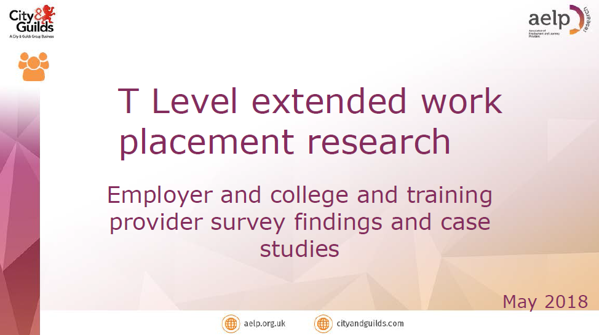
Qualifications Wales Review of Construction

In February 2018, Qualifications Wales published its sector review of qualifications and the qualification system in Construction and the Built Environment. For the full Building Futures report please visit the Qualifications Wales website:

http://qualificationswales.org/english/qualifications/vocational-qualifications/sector-reviews/construction-and-the-built-environment/

People Power Research
New research available from City & Guilds on how employers are faring in terms of recruiting and training the skilled workers they need to thrive and the challenges they see on the horizon. This research was done in partnership with Emsi to consider the current state of the UK labour market and predict what it may look like in the coming years.

https://cityandguildsgroup.shorthandstories.com/people-power/index.html

News and Policy media round-up

FE Week - The value of apprenticeships in the construction industry

Concern has been raised by construction industry experts about a shortage of skilled workers. It was revealed by City & Guilds that 87% of employers last year were struggling to get hold of the necessary number of skilled workers. One way to combat this, according to experts, is to have more apprentices in the industry. It’s thought that apprenticeships could be crucial, especially following Brexit.

READ MORE ►

MBS - Sector Deal for Construction finalised

Speaking at the launch of the Sector Deal, Greg Clark MP Secretary of State for Business, Energy and Industrial Strategy said: “This Sector Deal is supported by the biggest government investment in construction for at least a decade and will drive economic growth and create well-paid, highly skilled jobs in every part of the UK.”

READ MORE ►

DfE - Education Secretary sets vision for boosting social mobility

In a speech delivered by education Secretary Damian Hinds on social mobility, he made the following points on technical education:

- We need to consider whether a traditional degree at university is the right option for young people, including those from more affluent backgrounds.
- Technical education in this country - a country, by the way, with a distinguished history of technical brilliance - has long been seen by many as the second-best option to academic study and university.
- This government is committed to making technical education a first-class option through the £500 million investment in T Levels qualifications that will be on a par with A-levels as well as high-quality apprenticeships, including degree-level apprenticeships.
- Employers are helping to set the required standards for T Levels and apprenticeships guaranteeing they will have real currency in the labour market.
- The goal is that in future, all young people, whatever their background, will have much better choices when they start thinking about their post 16 and their post 18 destinations.

READ MORE ►

TES - A third of apprenticeship providers dormant

Almost 1,000 approved providers have not delivered a single apprenticeship, according to the AELP. Since the register was introduced by the Education and Skills Funding Agency in March 2017, 1,708 providers were approved, there have been just two large tranches of new providers added to the list. Currently, there are 2,957 providers on the register.

READ MORE ►
FE Week - Apprenticeship system expansion delay could leave 1,500 providers out in the cold

Over 1,500 training providers on the government's apprenticeships register will not have direct access to funding for small employers until at least a year later then planned.
The agency had planned that all employers would be able to use the apprenticeship service to access apprenticeship funding from April 2019, but this has now been delayed.

READ MORE ►

HR Director - Mishandling of Levy reforms see Apprenticeship opportunities slump

This week AELP chief executive published an article in the HR Director magazine, during which he expressed his concern that thousands of young people receiving their A-level results this week, will be disappointed to find that the debt-free choice of a higher or degree level apprenticeship may not be available.
He went on to point out that the increasing of higher and degree apprenticeship opportunities for the first nine months of 2017-18 is miniscule compared with the English student applications to university.
He also went on to identify some aspects of the apprenticeship reforms they feel are responsible for the disastrous overall fall in opportunities and provided suggestions.
One of these is to suspend charging SMEs for taking on young apprentices. He went on to say that he believes that the government is taking far too long to act after months of decline and that it should also use its post 18 review of education and funding to help boost numbers.

READ MORE ►

CIPD - Reforming technical education: Employers' views of T Levels

New CIPD report shows employers are positive about T Levels, but 60% have not heard of the new qualifications and work experience requirements may prove problematic

Three-quarters of UK employers (74%) have said they would not be able to offer T-Level students the minimum required amount of work experience needed to gain the qualification.

The new T-Level study programme, set to sit alongside apprenticeships and A-Levels, will be introduced in 2020. However, the CIPD’s survey of more than 2,000 employers finds that 60% still have not heard of the new qualifications.

Over a third of employers (35%) report that they have not provided any form of work experience within the last 12 months. Of those employers that do offer work experience, nearly two-thirds (62%) only offer placements typically lasting less than 15 days and a quarter of employers (24%) offer placements of just 5 days, showing the significant jump needed to help T-Level students reach the minimum required amount of 45 days. One in five employers (22%) said they would be able to offer the required work experience but would need a financial incentive, 10% said they could only offer two- or four-week placements, and a quarter (24%) said they would not be able to offer work experience at all.

Despite this, employers appear broadly supportive of the new qualifications, with almost half (44%) saying that they thought it would make a positive difference to young people’s employability, and two-fifths (41%) saying they would value the breadth of skills and understanding that they would bring to the labour market.

READ MORE ►

Tell us what you think
City & Guilds Construction is a newsletter that brings together all of the key developments from City & Guilds relevant to Construction skills learning across England, Scotland, Northern Ireland and Wales. It contains updates on public policy and other information we think you might be interested in.

Each edition is numbered, so we can refer back to previous issues or tell you when information has been superseded.

For specific queries and enquiries please contact our dedicated customer support team: CentreSupport@cityandguilds.com

Meet the team:

Ed Shaw
Industry Manager
edward.shaw@cityandguilds.com
02072943314

Ian Roberts
Technical Advisor
Ianm.Roberts@cityandguilds.com
07826903967

Paul Brown
Technical Advisor
Paul.brown@cityandguilds.com
07872463185

Please follow us on twitter @ConstructionCG

Thank you for your continued support.

Every effort has been made to ensure that the information contained in this publication is true and correct at time of going to press. However, City & Guilds’ products and services are subject to continuous development and improvement and the right is reserved to change products and services from time to time. City & Guilds cannot accept responsibility for any loss or damage arising from the use of information in this publication.© 2018. The City and Guilds of London Institute. All rights reserved. City & Guilds is a trademark of The City and Guilds of London Institute, a charity established to promote education and training registered in England & Wales (312832) and Scotland (SC039576).

