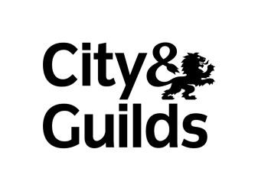June 2014

City & Guilds

500/7738/7 Level 1 Award in Business and Administration

OVERVIEW
1 Giltspur Street
London
EC1A 9DD
T +44 (0)20 7294 2468
F +44 (0)20 7294 2400 www.cityandguilds.com

• What does this qualification cover?

This qualification covers the essentials of business administration, allowing the learner to develop the skills and knowledge required in a business environment.

The following areas that can be covered within this qualification:

• Working in a business environment
• Creating business documents
• Making and receiving calls
• Handling mail
• Working as part of a group.

All learners will cover the mandatory core units and then a choice of optional units. This is a Framework qualification.
Who could take this qualification?

There are options for those who are new to the job and want a solid base of knowledge and skills to help you succeed as an administrative role. Level 1 will suit you if you are working in or want to work in a business support role and you're interested in learning how to carry out everyday administrative tasks.

This qualification is suitable for anyone from 16 years old or over. WHAT COULD THIS QUALIFICATION LEAD TO?
This qualification could lead to jobs such as:

• Receptionist
• Administrator
• Secretary
• Personal assistant

The learner could progress onto an apprenticeship at Level 2 or 3 in Business
Administration or other qualifications such as:

• Level 2 and 3 Medical Administration / Secretarial qualifications (5519)
• Level 2 and 3 Business and Administration NVQs (4428)
• Level 2 and 3 Certificate and Diploma for Legal Secretaries (7655)
• Level 2-4 Customer Service NVQs (5530)
• Award, Certificate or Diploma for IT Users (7574)
• Level 3 Awards, Certificates and Diplomas for IT Users (7575)
• ILM leadership and management qualifications.

WHO SUPPORTS THIS QUALIFICATION?
This qualification is supported by the following registered providers: CAD Centre UK
DC Training and Development Services
Morthyng Vocational College
Qube Learning (Qube Qualifications and Development Ltd) YH Training Services Ltd

2 of 2

