Unit 309: Produce and present advanced desserts and dough products using standardised recipes

Handout 6: Strawberry, peach and almond tart

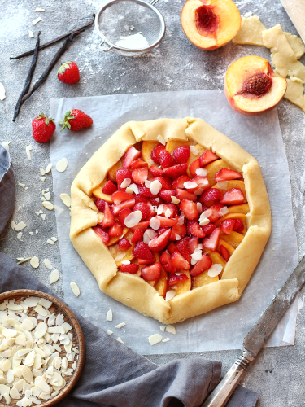

Ingredients

Pâte brisée
- 250g plain flour
- 100g butter
- 20g sugar
- 1g salt
- 50g ice cold water

Almond paste
- 200g ground almonds
- 90g icing sugar
- 90g caster sugar
- 1 tbsp rum
- 1 egg

Filling
- 2 punnets strawberries, washed and halved
- 3 peaches, washed and sliced
- 30g flaked almonds
- caster sugar, for dusting
- icing sugar, to serve

Method

- To make the pâte brisée, mix together the flour, butter, sugar and salt in a bowl to a fine breadcrumb consistency.

- Slowly add the iced water and mix until it comes together in a ball. Wrap in cling film and leave to rest in the fridge for an hour.

- After this time, remove the dough from the fridge and roll out thinly on tray lined with baking parchment (approximately 3mm thick) before returning to the fridge to rest again.

- Meanwhile, make the almond paste by mixing everything together in a mixer fitted with a paddle attachment, until incorporated as a fairly stiff paste.

- Wrap the paste in cling film and place in the fridge to rest for an hour. Remove and roll out to the same thickness as the pastry and return to the fridge again.

- Once both sheets are chilled, cut the pâte brisée into a rough circular shape using a sharp knife and discard the trimmings. Cut the almond paste into a similar circle, about 2cm smaller than the pastry.

- Dust the pâte brisée with caster sugar and turn over, so the sugared side is now on the bottom (still on the lined tray).

- Place the almond circle over the centre of the pastry, leaving a 2cm rim. Cover with the halved strawberries and sliced peaches and sprinkle over the flaked almonds.

- Fold the pastry edge over in towards the middle, crimping it together roughly to form an edge.

- Preheat the oven to 180°C/gas mark 4.

- Once the edge is sealed all the way around, bake in the oven for 30 minutes.

- Remove and allow to rest for 10 minutes before dusting with icing sugar and serving, perhaps with a quenelle of clotted cream or ice cream.

