Suggested inspection routine for students to learn.
This document must not be used during the practical assessment.

Start sitting in the driver’s seat

Check seat adjustment, locks in various positions.

- Commence on the N/S of the vehicle and check all testable items; N/S mirror if obligatory, open passenger door from inside, SRS,

- working across the front of the vehicle, driver’s view of the road, rear view mirror, lighting and other testable controls, ESC, sun visor, steering wheel checks. Play in upper bearing, security of top mount and steering wheel controls, including horn,

- Move down column, indicators, light switch, wipers, hazards (Ignition on and off).
Pump out servo (Engine off), master cylinder checks sponginess and creep, gentle pressure then rapid pressing of pedal.

Start engine with pedal depressed and note pedal drop indicating correct servo function

(With full pressure systems, ensure that there are two further applications after buzzer/warning light illuminates – see manual for further details.)

Check all testable warning lights, TPMS, ABS etc.

- move to O/S of vehicle (German cars tend to have the light switch to the right of the steering wheel), view to rear through external mirror

- Engine still running, (Vehicle on hard standing, not on turn plates), check for PAS operation, open driver’s door from inside, step out but hold onto the steering wheel and check free play looking at the O/S road wheel.

Use inspection lamp and check; Driver’s foot well area, rock steering wheel, (engine still running if PAS) and check steering column and U/Js etc., pedal box condition and security, side to side movement of pedals, anti-slip provision on brake pedal, rods, levers, clevises, locking devices etc. Prescribed Areas (Inspection may necessitate moving over to passenger side if there is a cross shaft)

Move out of vehicle.
Move to front of vehicle – stand back, check reg plate (Including correct number), lighting – condition and security.

Assistant gets in

Check testable lamps at front (Inc hazards ignition on and off)

Assistant out

Check headlamp alignment if equipment layout permits

N/S front, bumpers, sharp edges, security of number plate.

O/s front - move down the o/s of the car; side repeater (security), O/S mirror security,
Open Driver’s door from outside, body and structure – door aperture, sill, B Post (Prescribed Areas)

Seta back upright, check security. Is seat belt attached to seat?, seat security, seat belt security, seat belt condition, seat belt receiver security, interaction of belt with receiver, floor structure around driver’s seat.

Close door (testable item in itself)

Move to rear door

Open rear door from outside (testable item in itself); door aperture, structure, seat belt attachment, seat security, seat belt condition, security of rear of driver’s seat.

Close rear door (testable item in itself)

Move to O/S rear quarter; body structure, security, fuel filler and seal (if appropriate), security of lights.

Open Boot

Body structure, (finger and thumb) lift carpets open panels etc. if no tools required. Check seat belt mountings for rear seats and condition if appropriate.

Close boot – work down N/S exactly as per O/S back to front of vehicle.

Open bonnet. – Static inspection

Engine not running. Under bonnet examination, body and structure, steering, suspension, brake pipes and hoses, fuel pipes battery security and wiring, fluid levels, engine mountings, exhaust.

Assistant in (Vehicle on hard standing) Start engine, check fuel and brake lines again with engine running and brakes applied. Assistant shakes steering wheel – observe steering system for play etc.

Vehicle still on hard standing, carry out underside inspection, continue with steering shake check (engine running)

Move to front of vehicle – brakes on, engine running, check brake hoses and pipes, fuel system and pipes, exhaust (leaks)

Engine off – commence static inspection, move round in a box, from the driveshafts forward. starting at O/S front of vehicle. Check everything again, (brakes not applied), brake pipes, brakes, hoses, fuel lines, front of front suspension, steering etc.

Split remainder of car into 2 boxes down the middle of the car, starting at the front driveshafts backwards and work around each of the boxes.

Check all items, working from front box down the vehicle, if hoist design permits, ‘pop out’ half way down and inspect outer sill. Then ‘pop back in’ and continue round the boxes checking all items.
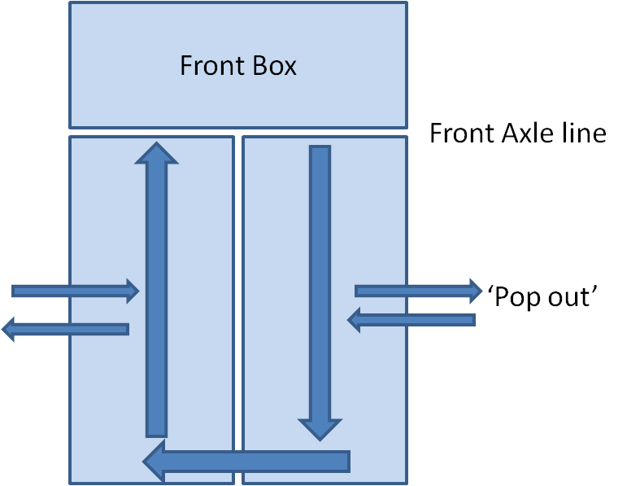

Vehicle still on hard standing; jack up rear. Examine rear of vehicle; suspension items now exposed, rotate wheels, check rims and sidewall (Inner).

Check corners, check centre of wheel (hub cap), valves, rim, outer side wall and tyre tread depth.
Rock wheels and rotate – check for roughness in bearing.

Check rear corners, body and structure, fuel tank, fuel pipes, brake components and different view of all components.

Lower vehicle

Move to front, jack up – determine where vehicle should be jacked dependent on suspension type.

Start at N/S; rotate wheel, check sidewall, rim, brake components and if FWD, follow driveshaft line checking gaiters while turning wheel, continue and do the same at O/S

*Rock top and bottom of wheel, bar under tyre, check top mounts

Put on lock, examine entire circumference of tyre, observe different view of components, move to other lock and repeat process.

*Repeat process with Assistant.

Move the vehicle (or plates, if sliding) so that it rests on unlocked turn plates

**If suspension is hanging free (e.g. struts) 12:00 shake and 3:00 & 9:00 push pull

- If suspension is such that vehicle is jacked under suspension arm, there is no requirement for this check.

**Repeat process with assistant

Raise hoist with assistant in the vehicle, engine running, still on turn plates, steering on full lock, “Left hand down” – carry out NS check, follow steering gear, rack gaiters to O/S,
“Right hand down”, check for fouling, repeat the process. (This inspection may need further inspection under the bonnet)

Lower hoist, assistant out – get in, engine running, move steering lock to lock and assess for tightness and roughness in the steering and where applicable, steering lock does not inadvertently engage,

Engine off, key out, check steering lock operation.

Move to RBT, Emissions and Headlight Alignment if appropriate

